

**User Guide**

R&D - VoteChain Team

April 2, 2018

**Project Coordinator:** Petteri Kaskenpalo

Lam Quang Vu

**Client:** Hoang Le Minh

**Supervisor:** Le Ngoc Son

**Team Members:** Nguyen Trong Tri

Pham Huynh Tri Minh

**Contents**

Directory tree 2

ENVIRONMENT 4

WorkFlow 4

CONNECT TO private network 5

Miner 5

Run Application 6

Pages 7

Register 8

Create Room 11

Join Room 17

Vote 20

Check Result 23

Check History 25

# Directory tree

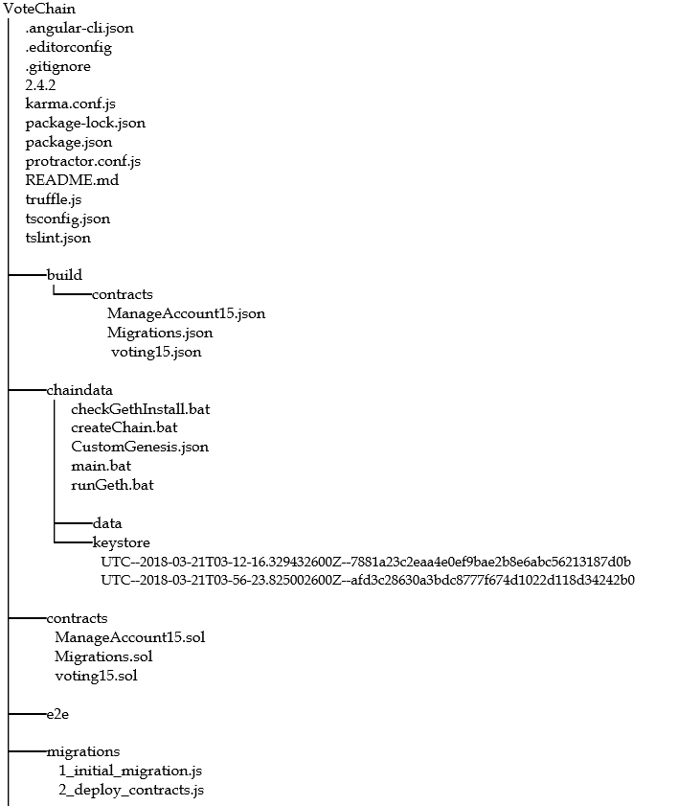

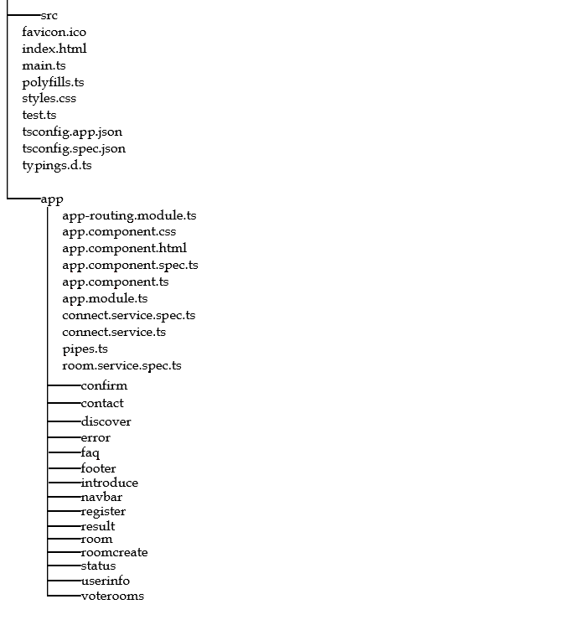

# ENVIRONMENT

Download and install:

Geth: <https://geth.ethereum.org/downloads/>

NodeJS: <https://nodejs.org/en/>

# WorkFlow

Using Blockchain technology leads to some advantages and disadvantages. In this system, all transactions were made that couldn’t be changed, need more time to submit transaction/ get data from the Chain, cost money for each transaction (not a big deal in the private network).

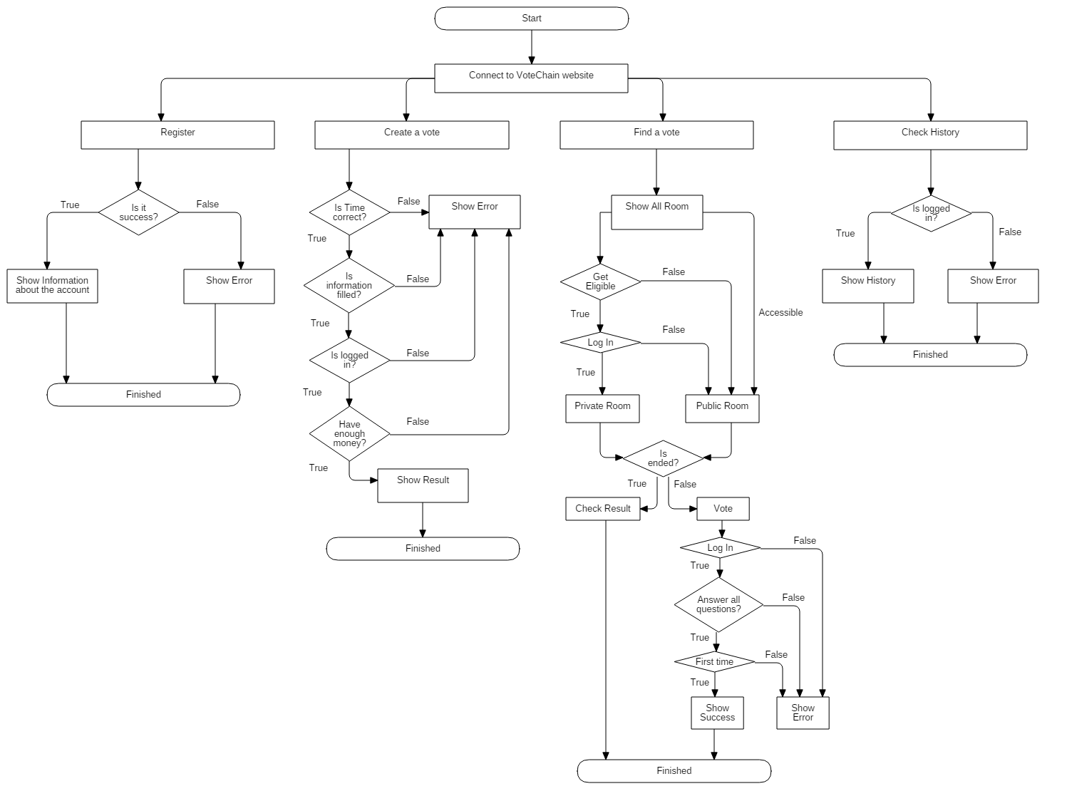

# CONNECT TO private network

Use the command in the directory that include the folder “chaindata”. This will connect to that data with RPC protocol and RPC API using the Network ID 1994:

geth --datadir=chaindata --rpc --rpcapi db,net,web3,personal,eth --rpccorsdomain="*" --networkid=1994

OR you can run file main.bat

Result:

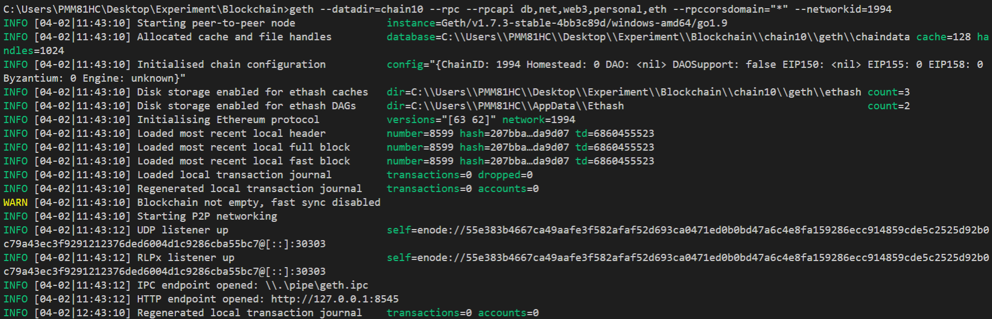

# Miner

This is an option for people who want to earn money and verify the transaction. In the private network, we recommend that Bosch should run at least 4 computers as miners to keep this application run smoothly (Hardware: i7 7700, RAM 8GB and HDD 1TB).

Use the command in any directory, make sure that you have connect to the network:

geth attach //Run console in the private network

miner.start() //Start mining, the default account will earn the reward in this network is account[0]

miner.stop() //Stop mining.

miner.setEtherbase(account) //Change the account will earn the reward

More information: <https://github.com/ethereum/go-ethereum/wiki/Mining>

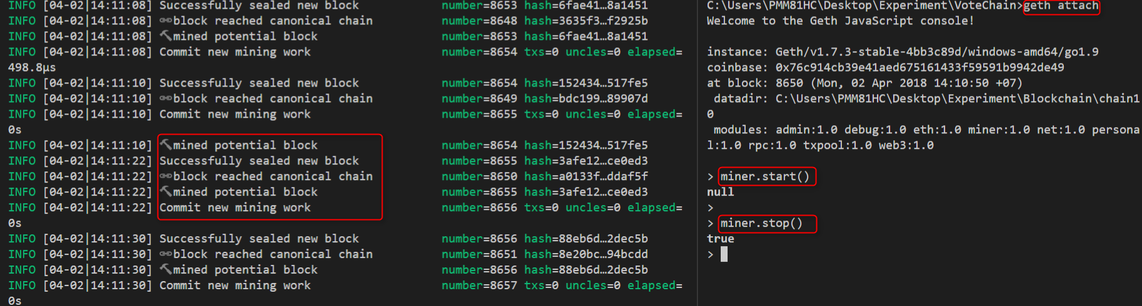

# Run Application

After clone the project, use the command in the directory VoteChain

npm install //install library, module

ng serve //run the application website

Open the browser and connect to: localhost:4200

In Command Line:

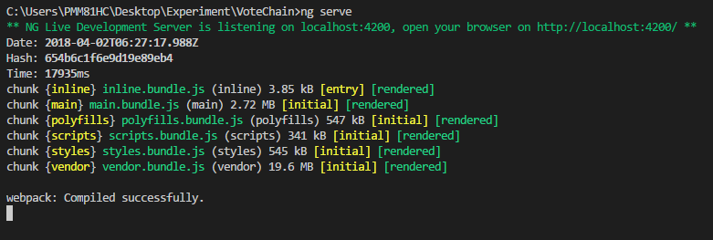

In Browser



# Pages

There are 5 main pages:

Introduction: this is an index page, show the overview of the project.

Discover: All documents about this project could be found here.

Vote Rooms: All created rooms will be shown here.

Q&A: Frequently Question and Answer

Contact: Information to contact us.

# Register

At the Index page, click on the “Hello, User’ then choose “Sign Up” to direct to the Register page.

At the Register page, fill in all information and if everything meet the condition, the Register button will available. Click on the Register button to sign up.

Make sure that there is a miner is working.

Condition:

ID: unique, combine letter and number, no special character, maximum 6 letters

Password: no restrict

Retype Password: the same with Password

Index page:

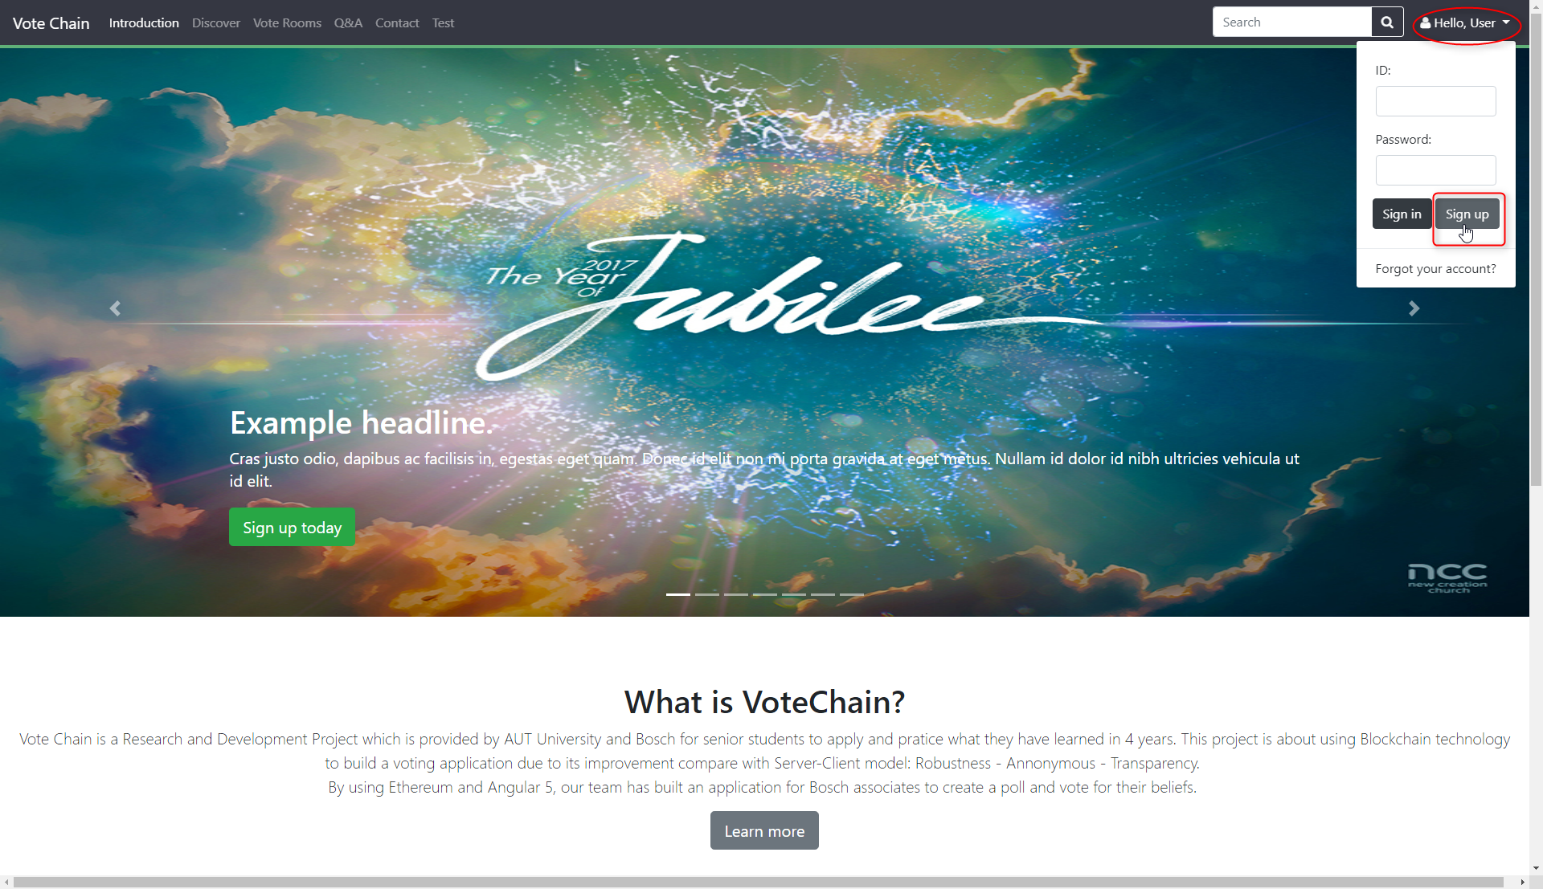

Register page:

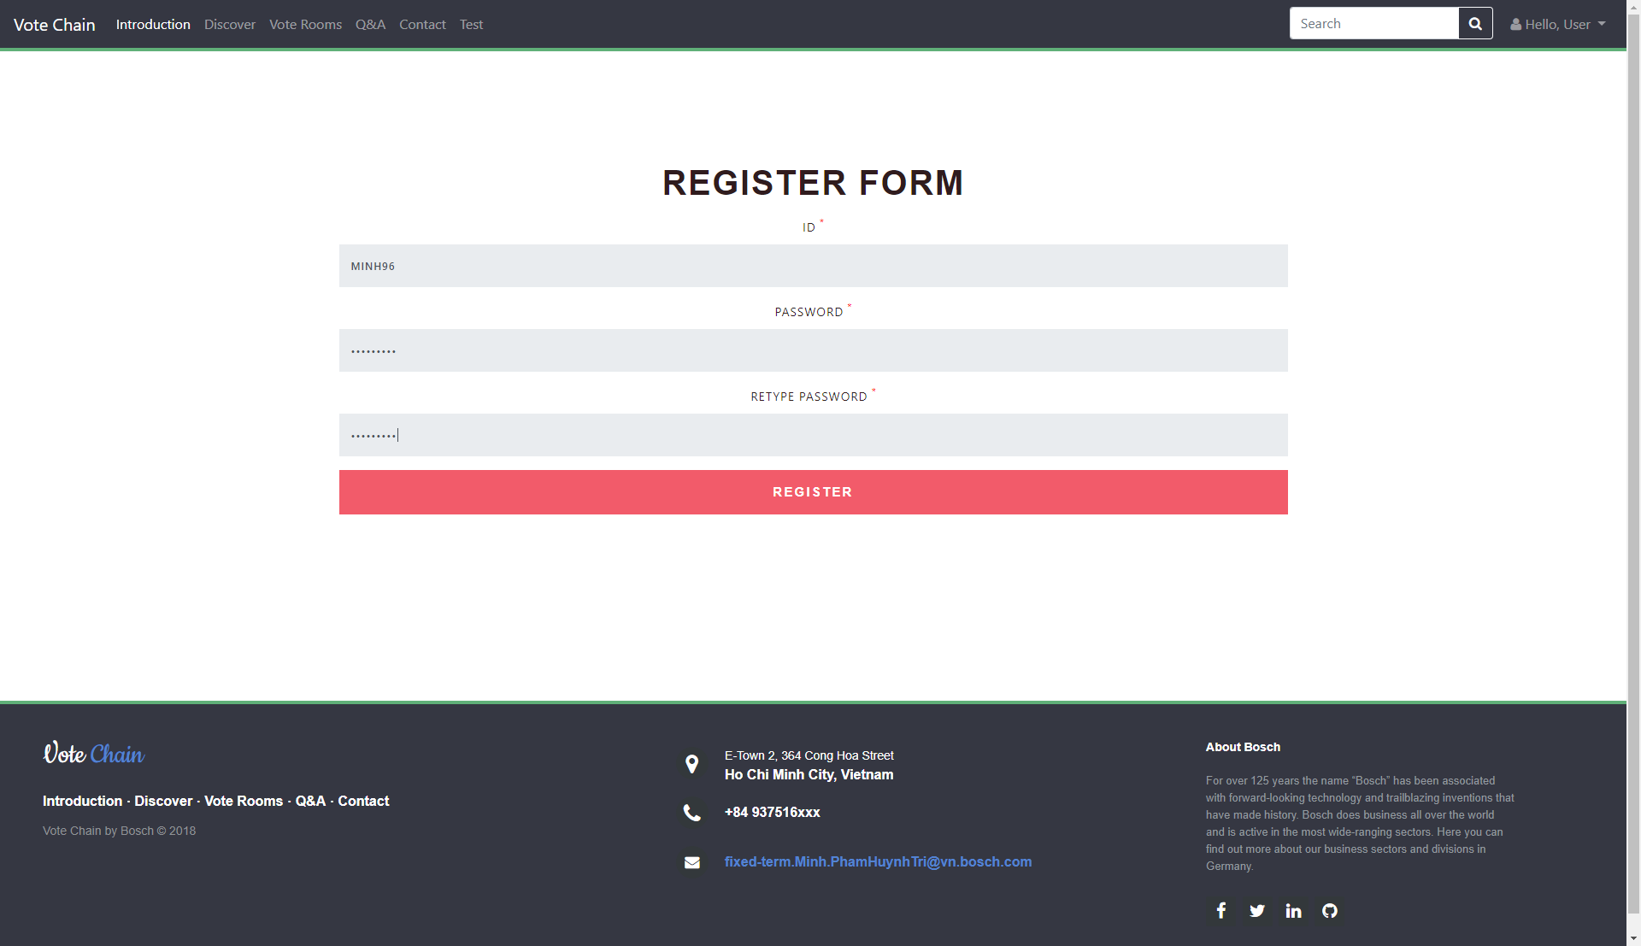

Submitting:

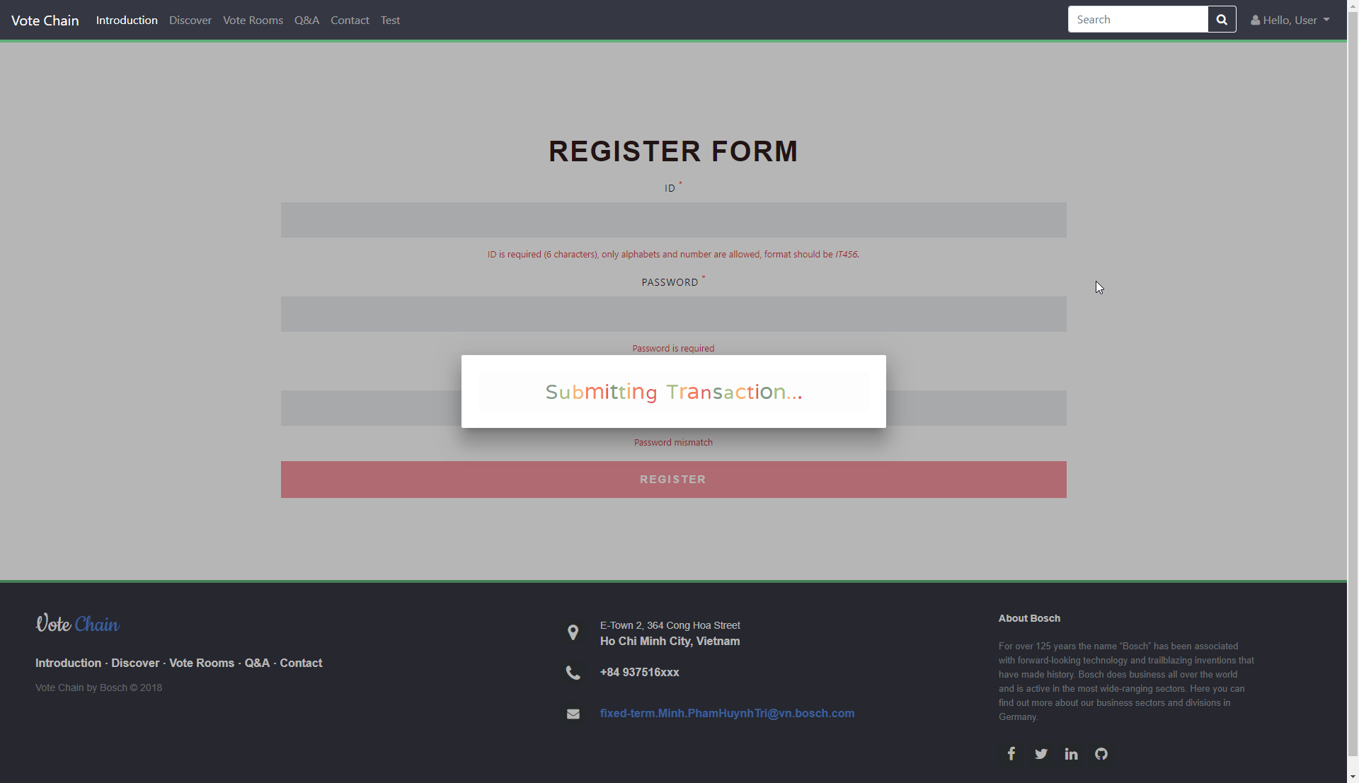

Success:

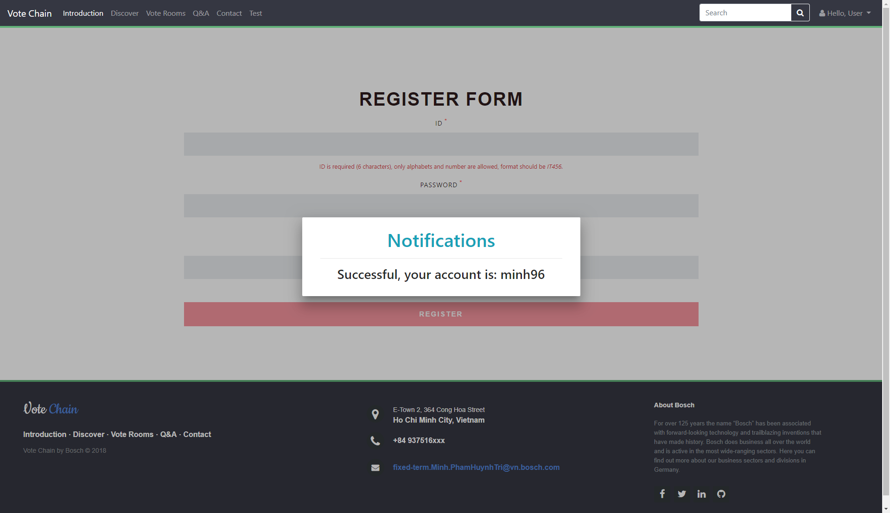

Error:

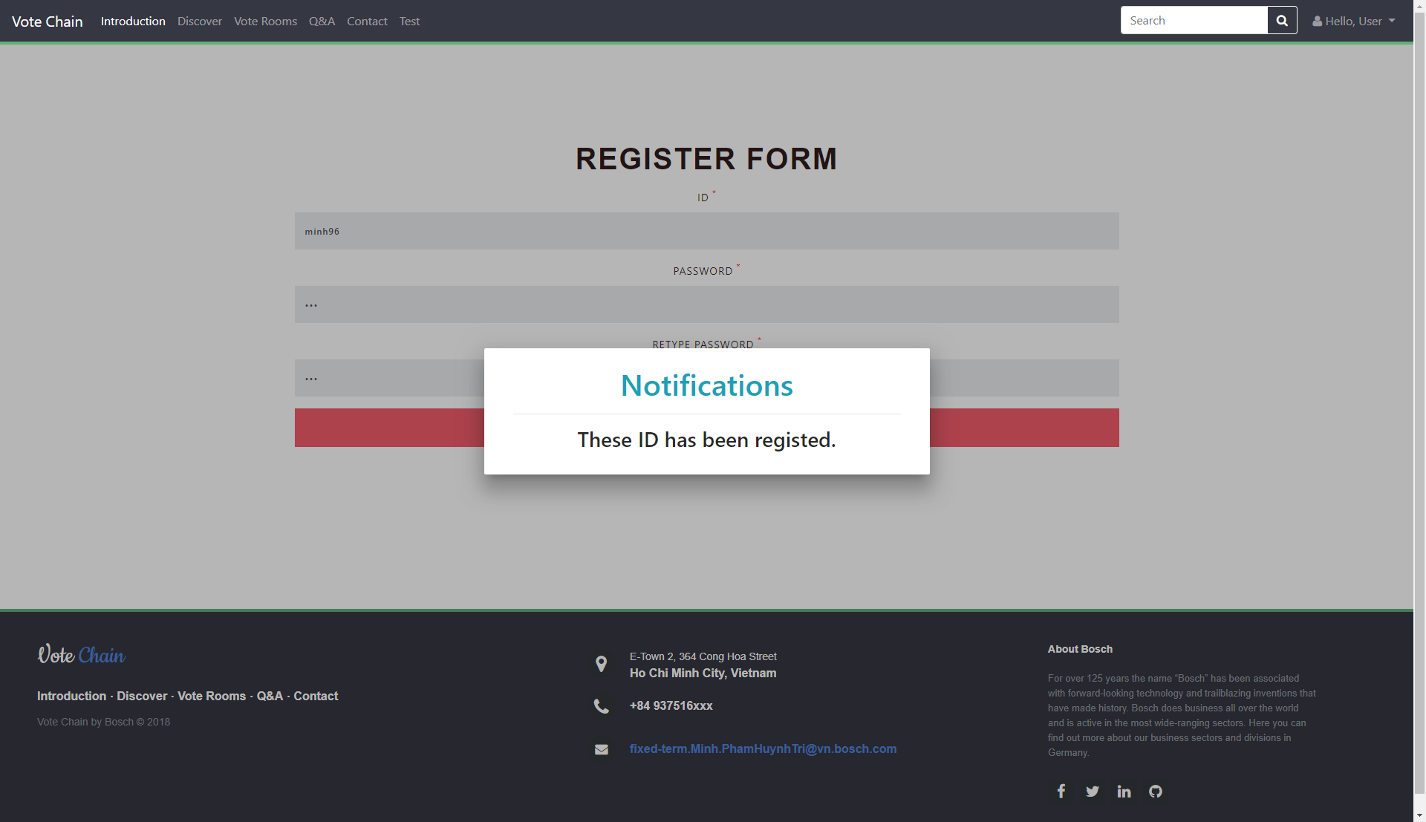

# Create Room

At the Index page, click on the “Vote Rooms”.

At the Vote Rooms page, click on the button “Create” on the top left.

At the Create Room page, start fill all information of the vote you want to create.

*If the room type is Private, you have to fill the IDs of people you want to invite to this vote, only they can see and vote in this room. Separate them by the semi-colon “;”

**Choose the number of Question you want to open and the number of Option for each Question. Remember that choose both of them first then input your questions and option OR you will have to fill again.

Maximum Questions: 10

Maximum Options for each Question: 5

Index page:

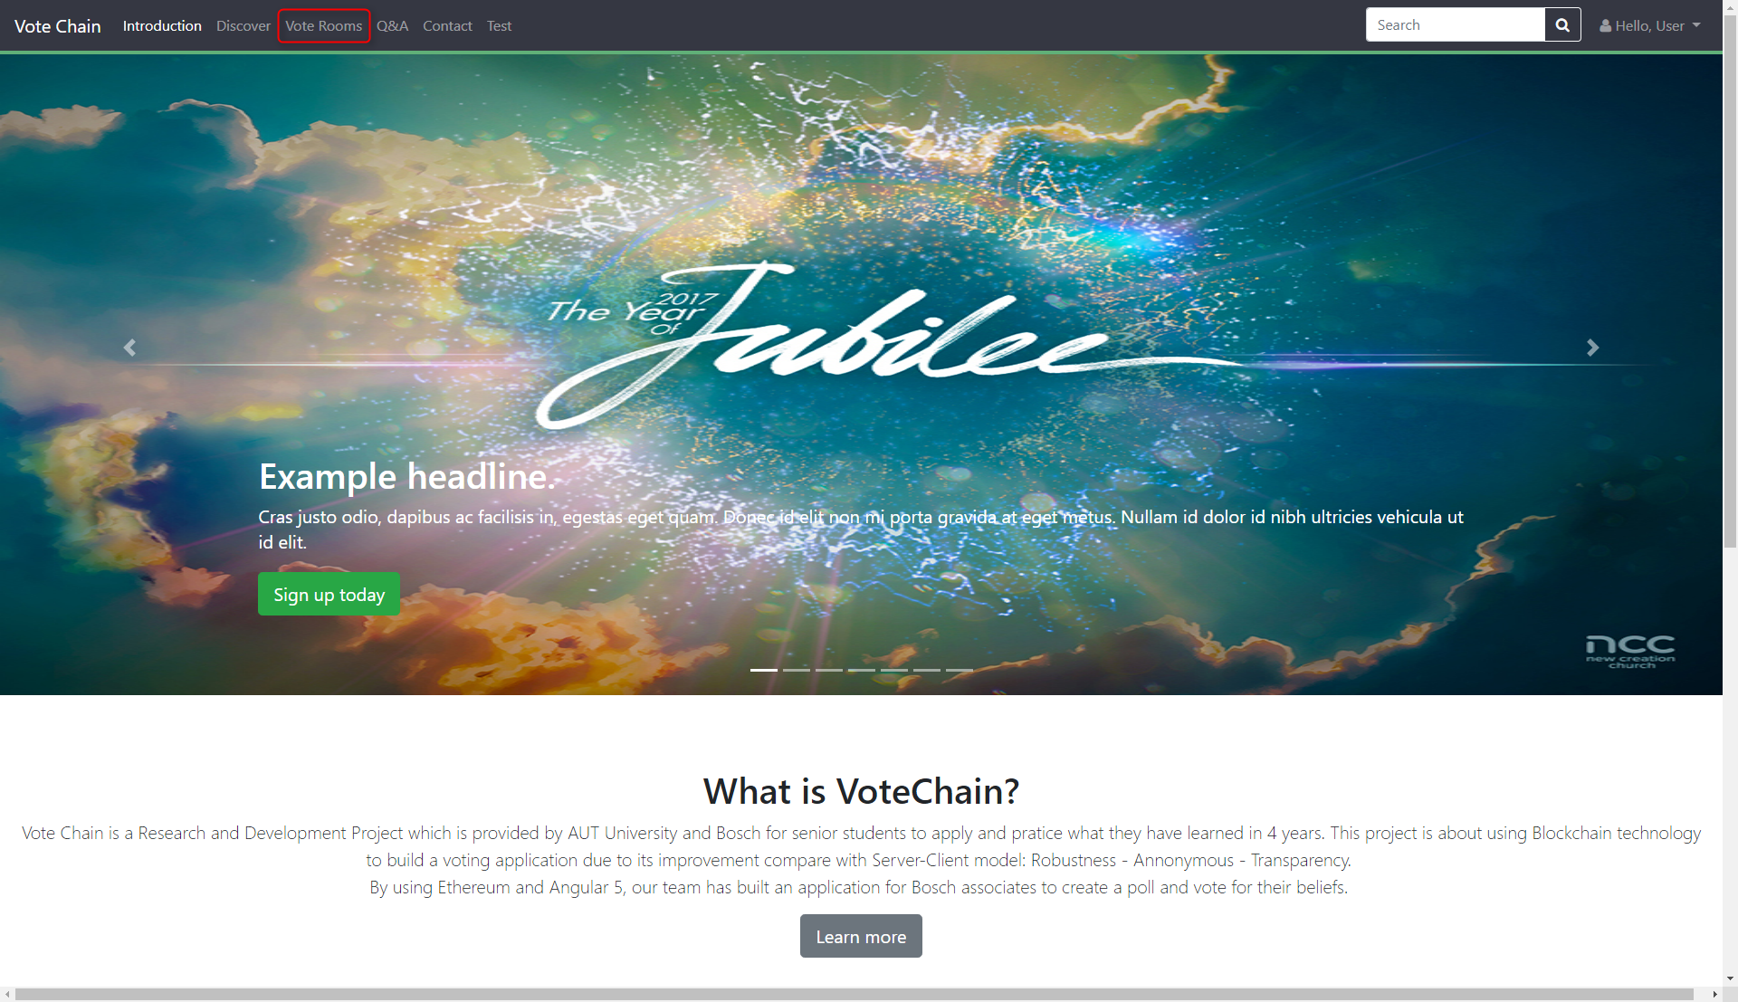

Vote Rooms page:

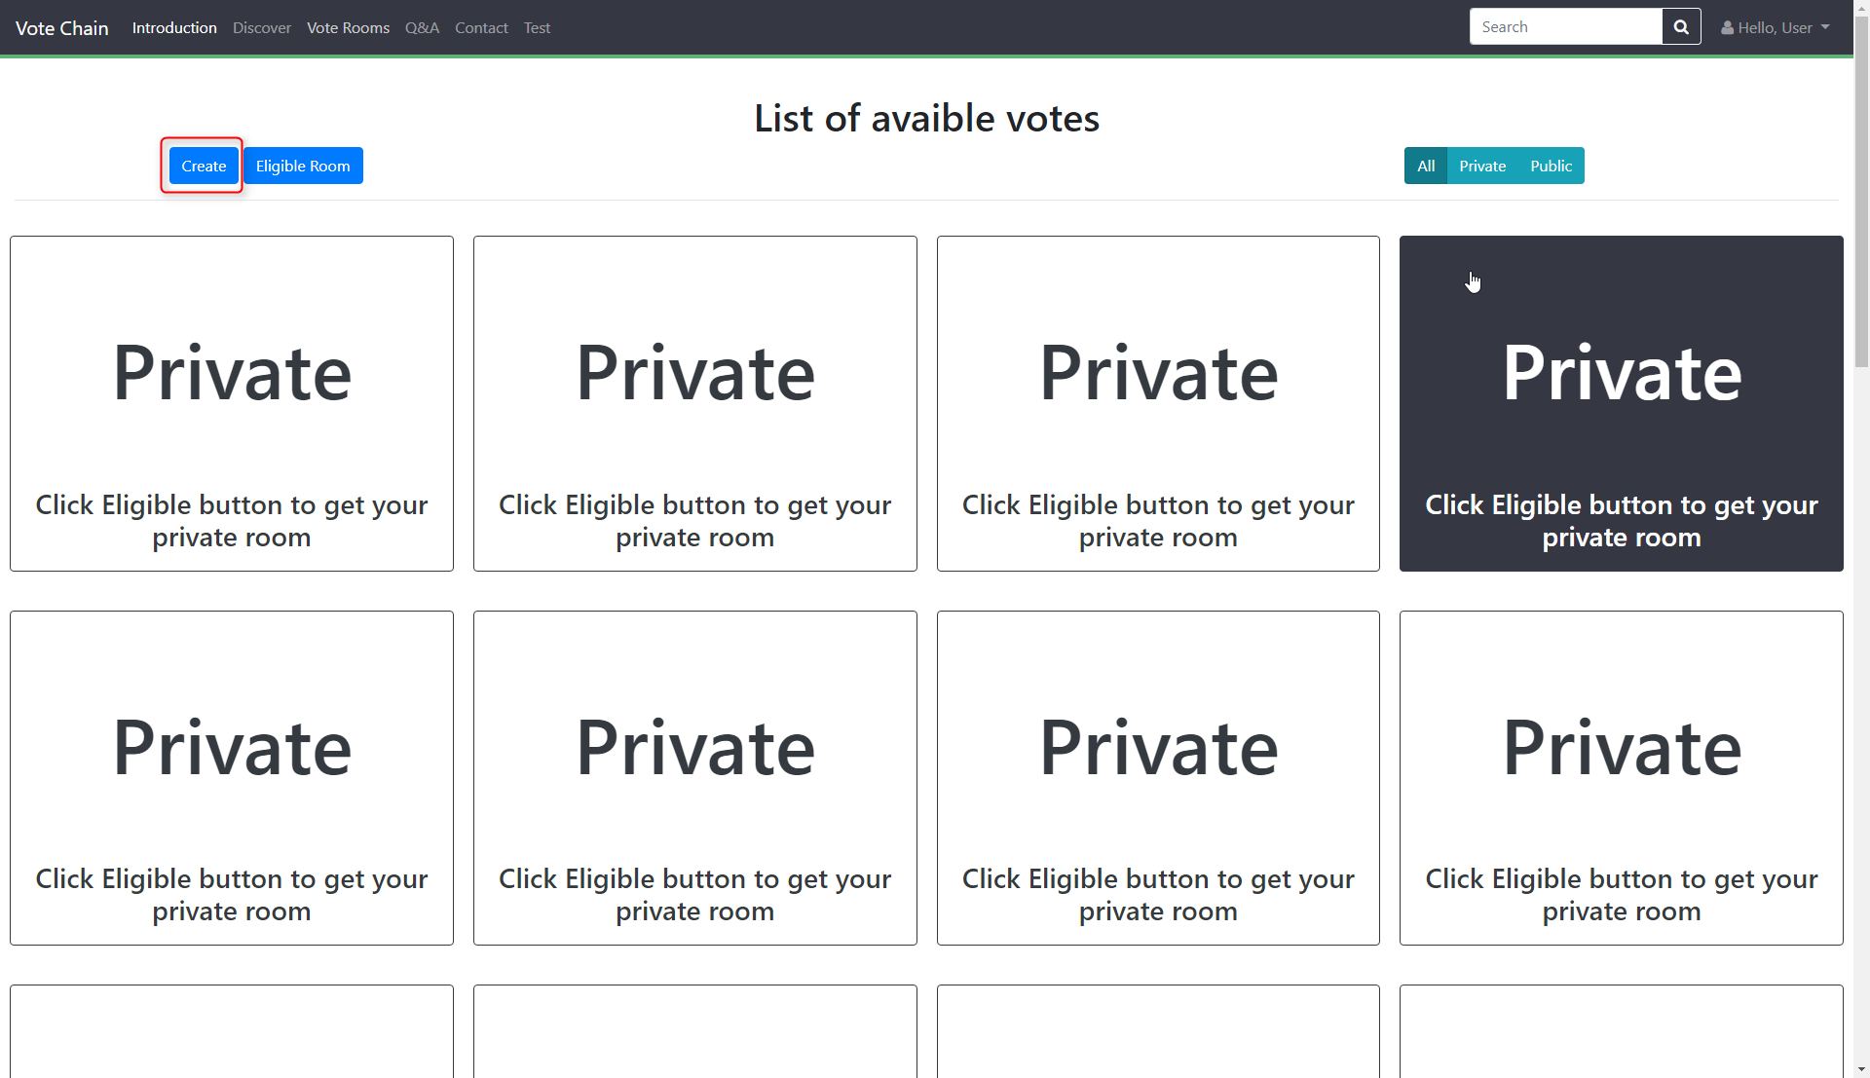

Create Room page:

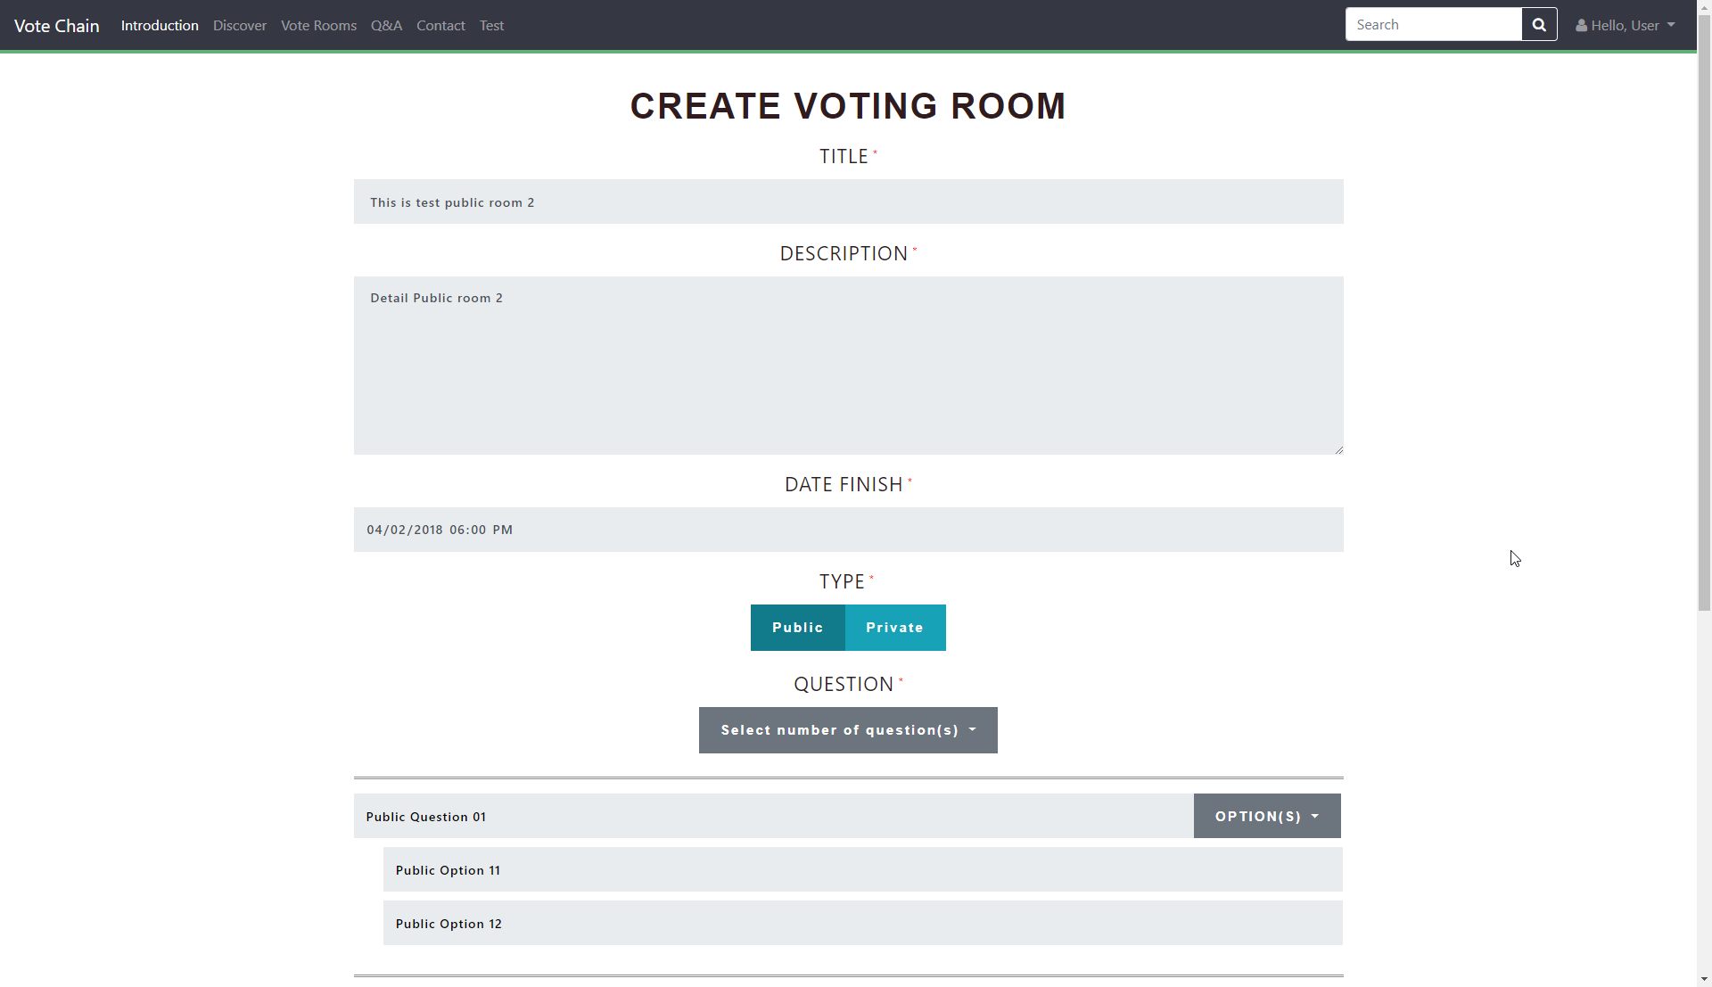

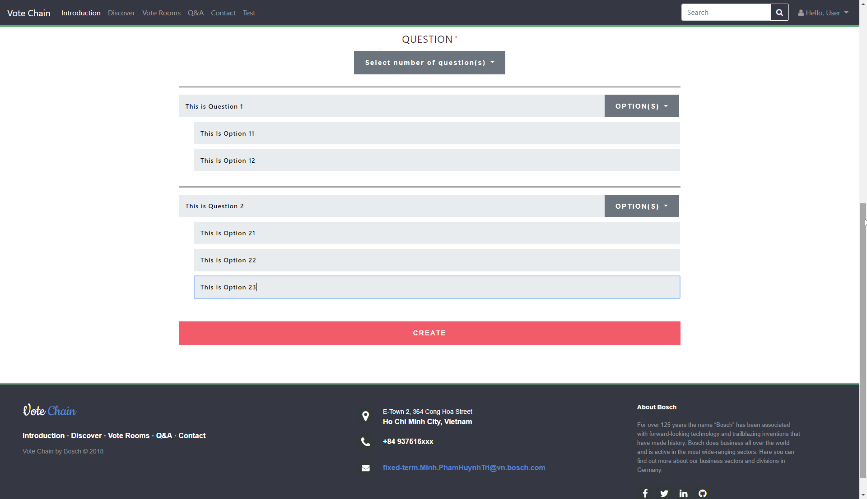

If choose Private Room: 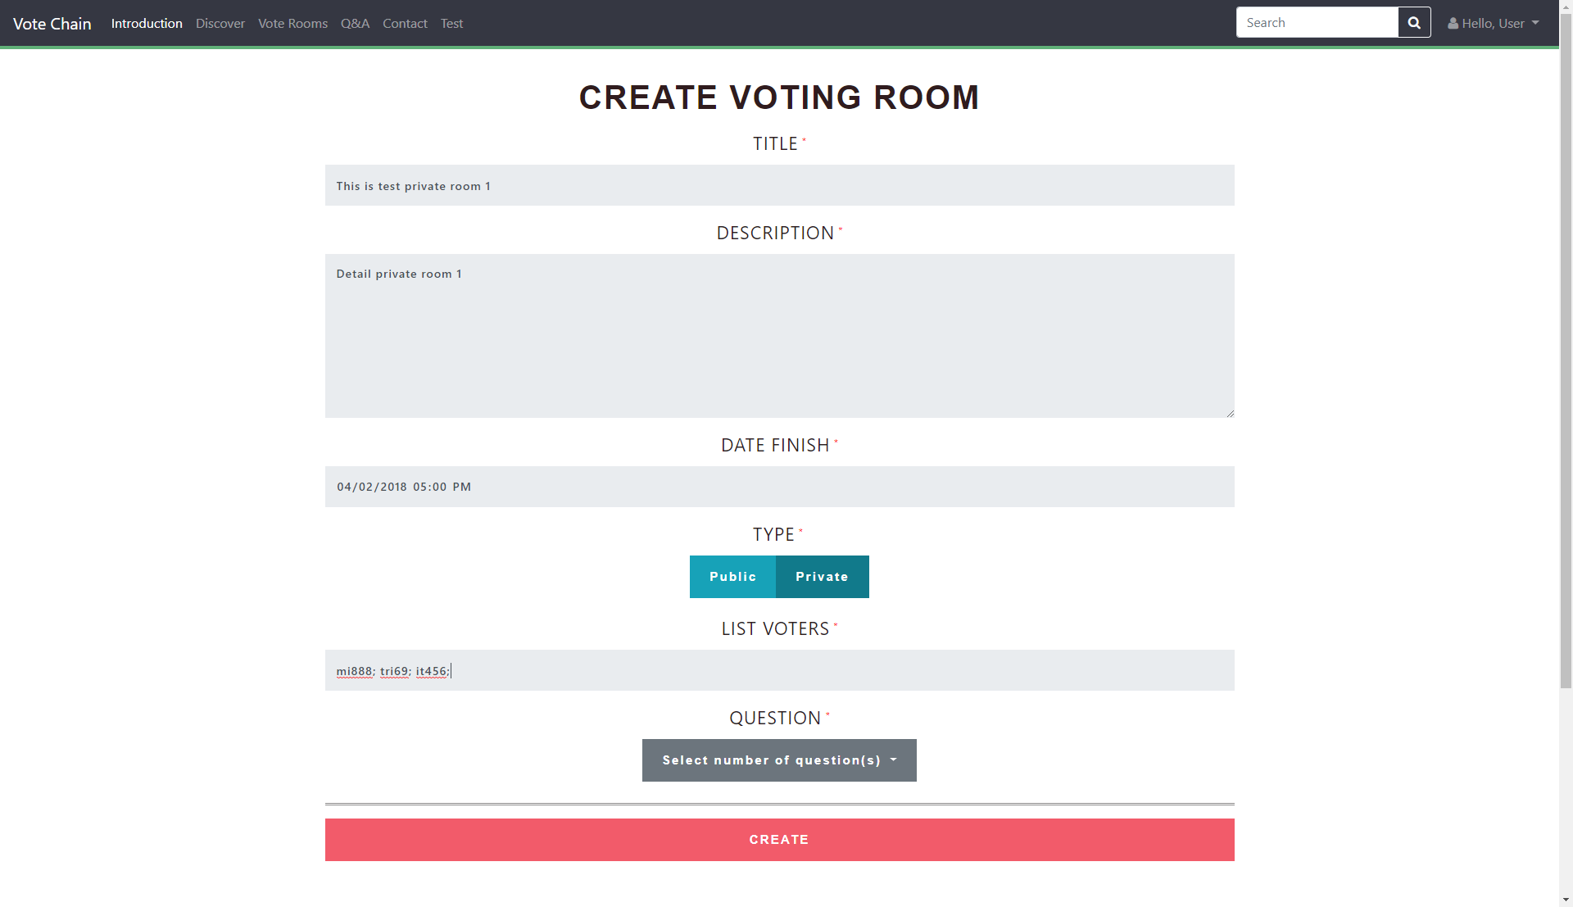

Login to confirm:

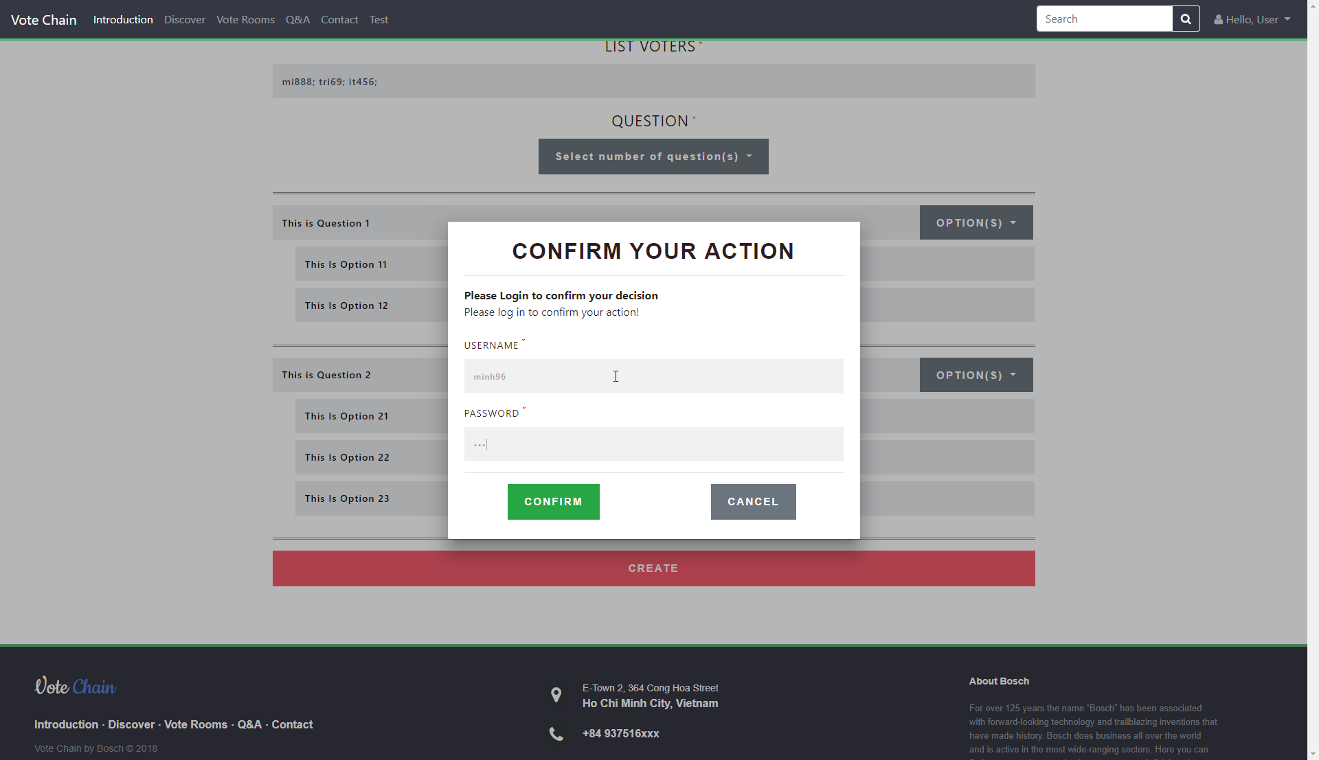

Submitting Transaction:

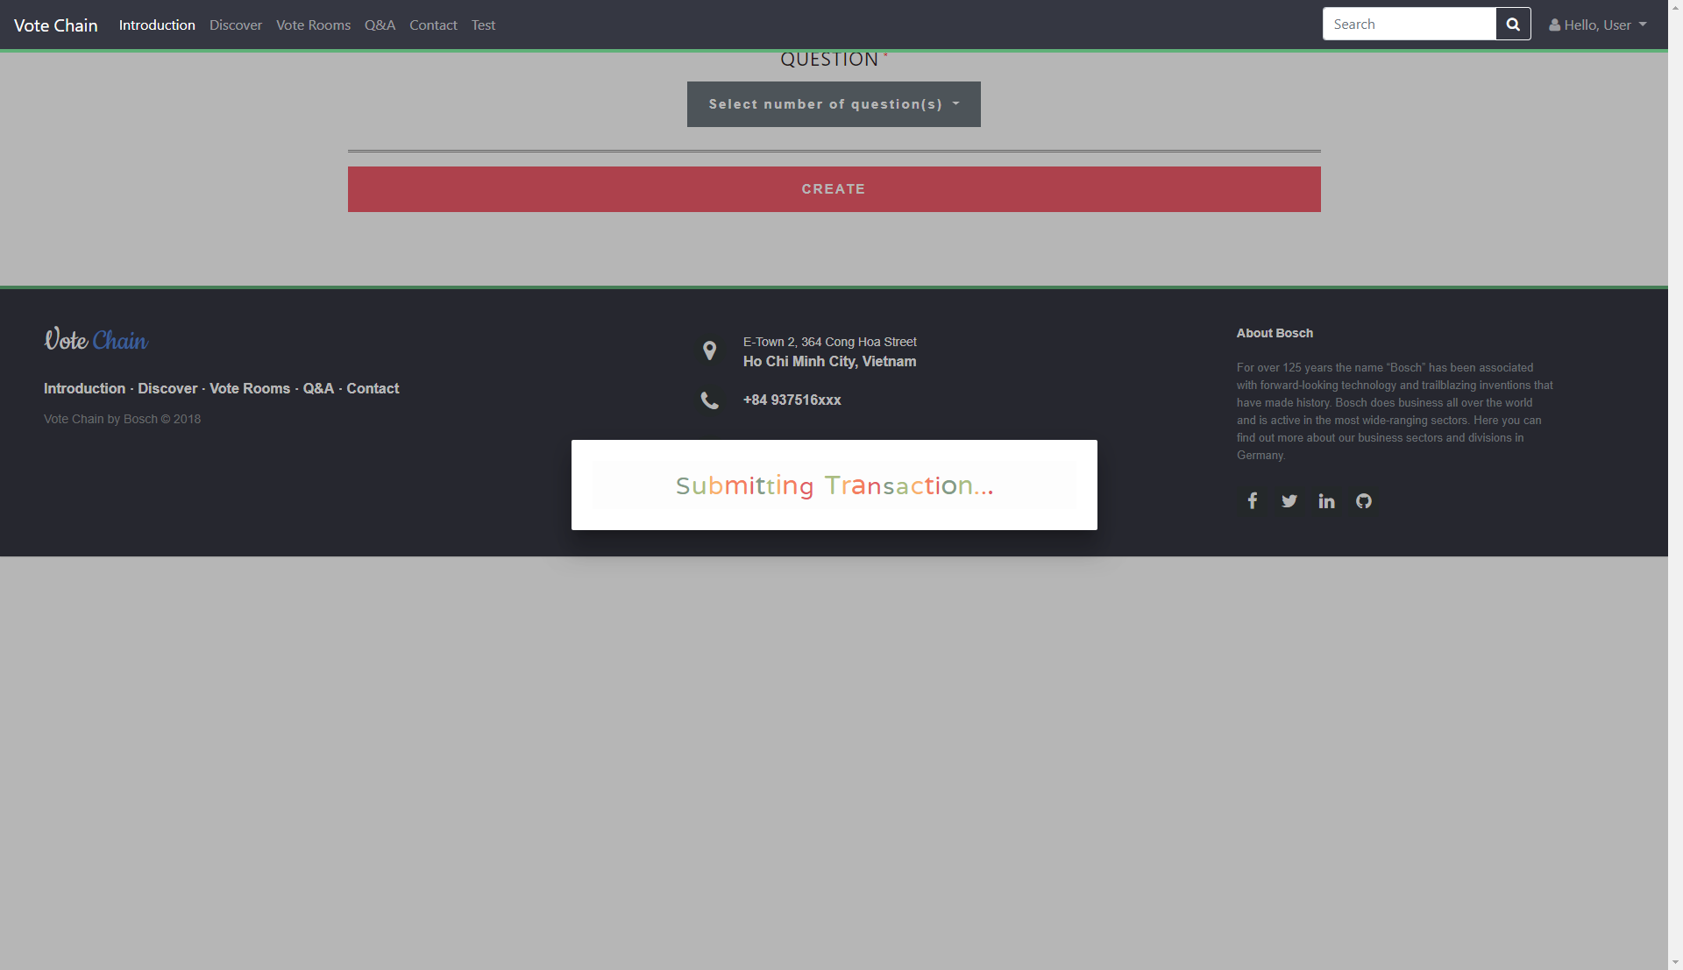

Success:

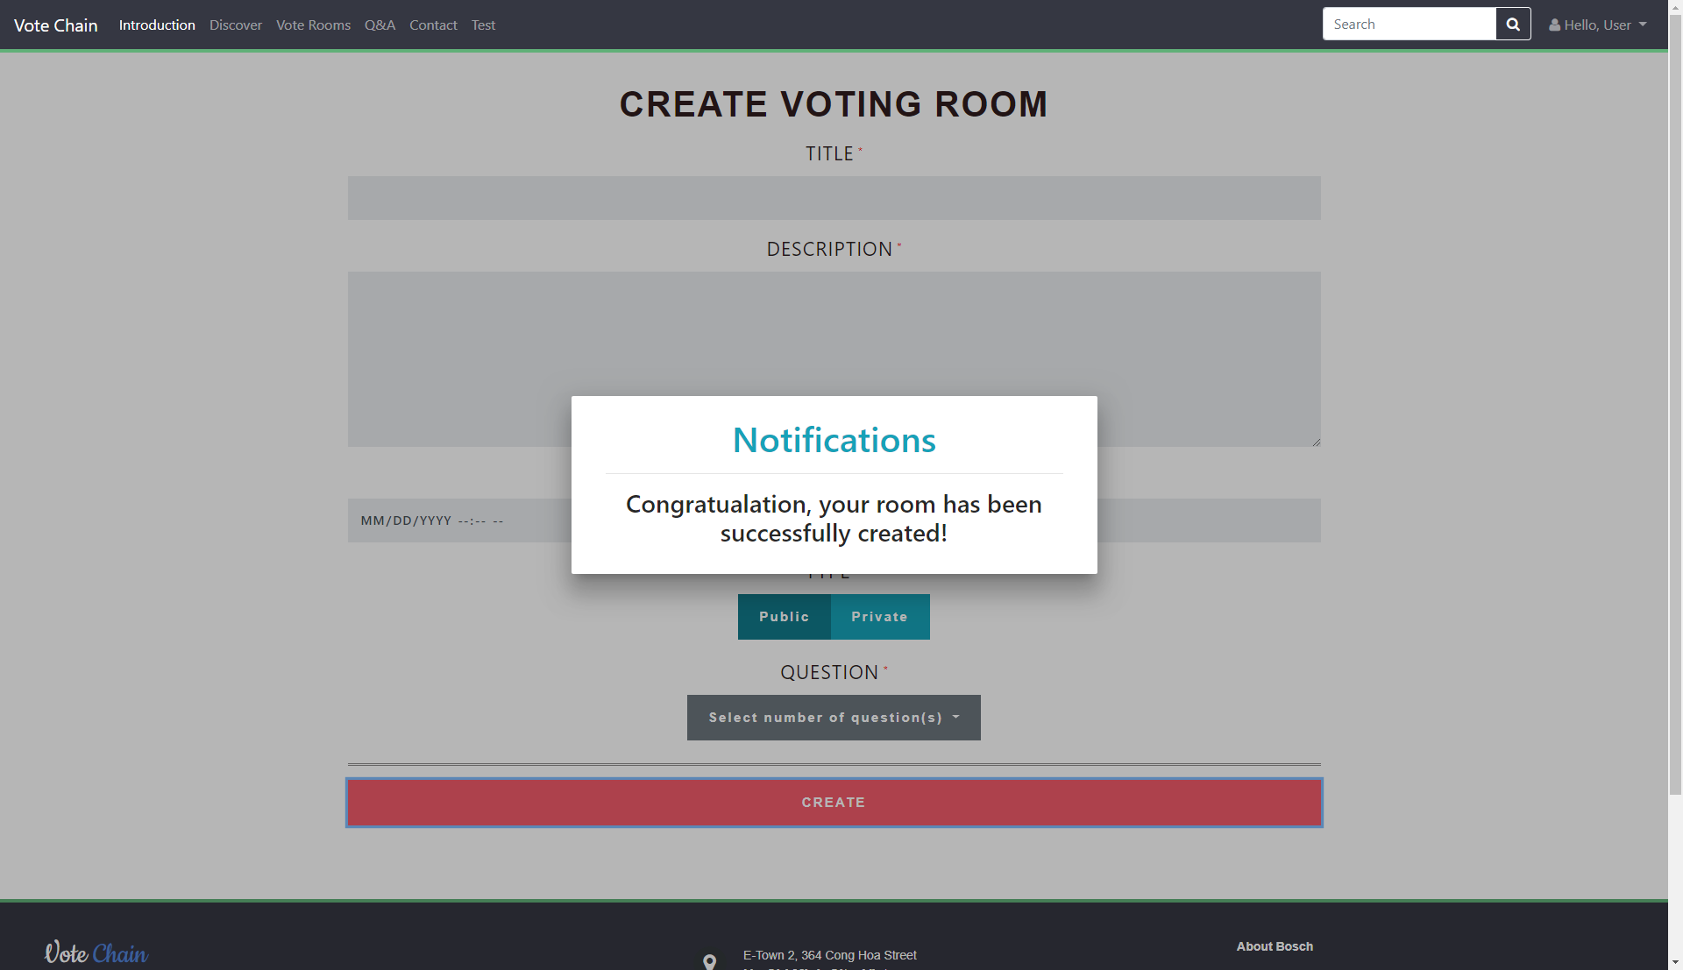

Result:

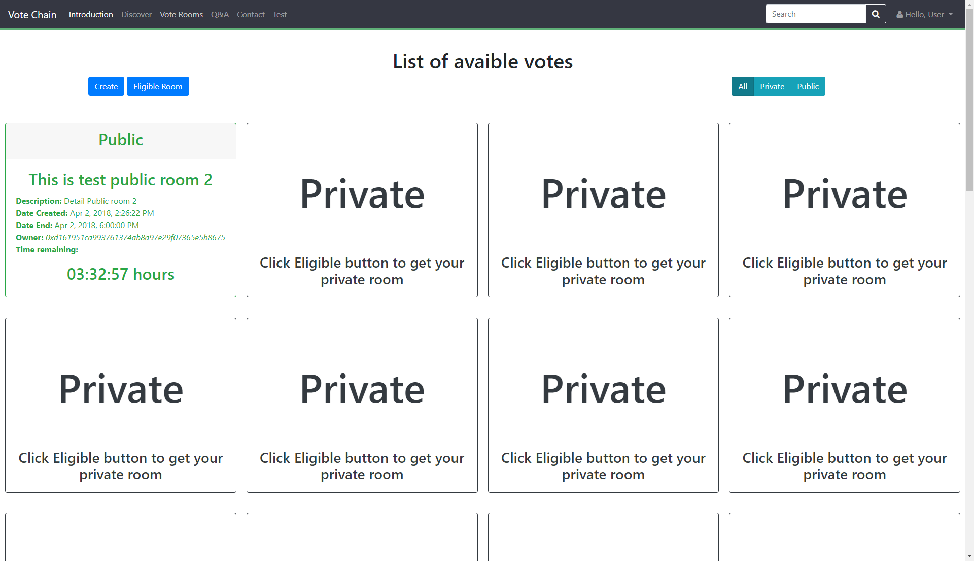

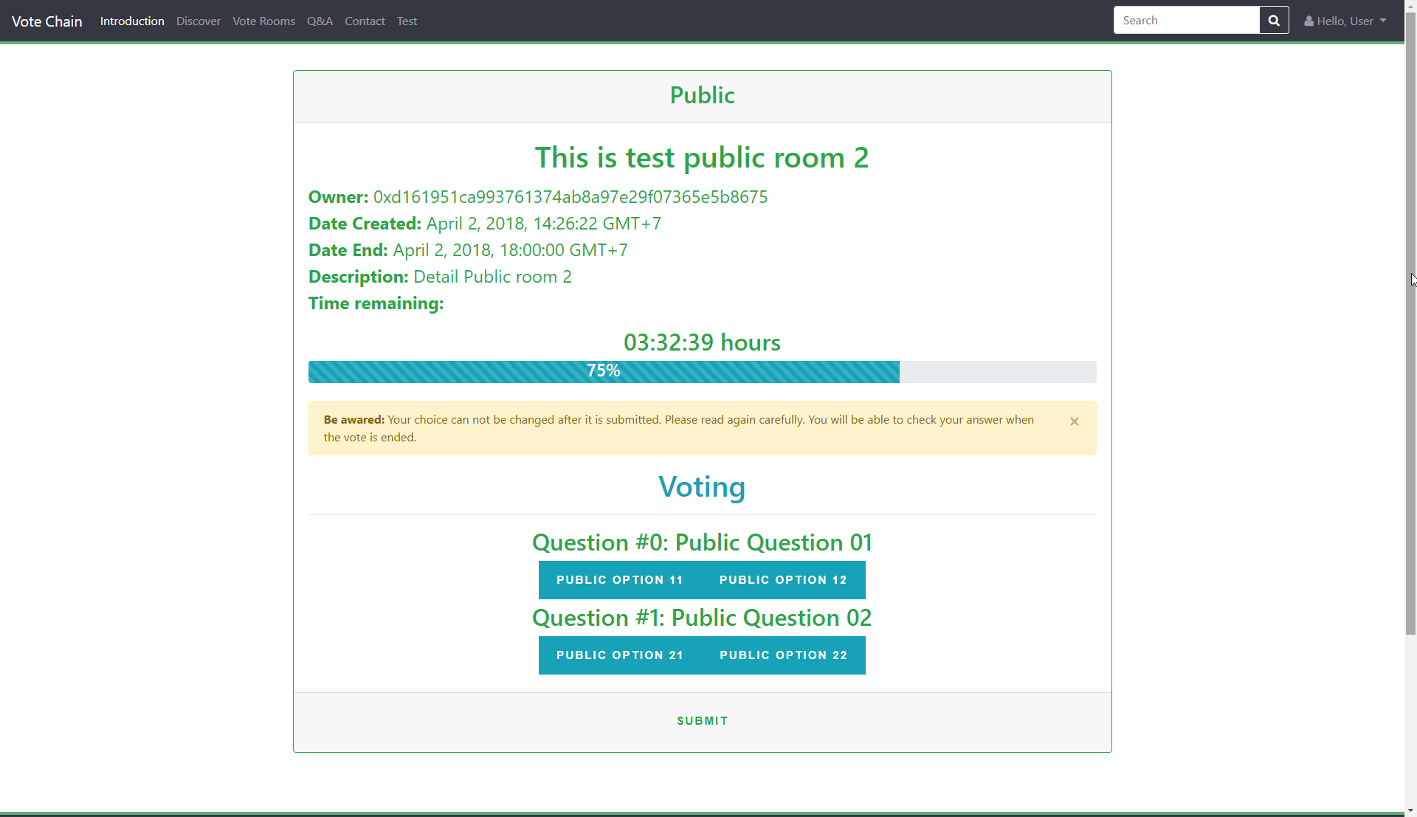

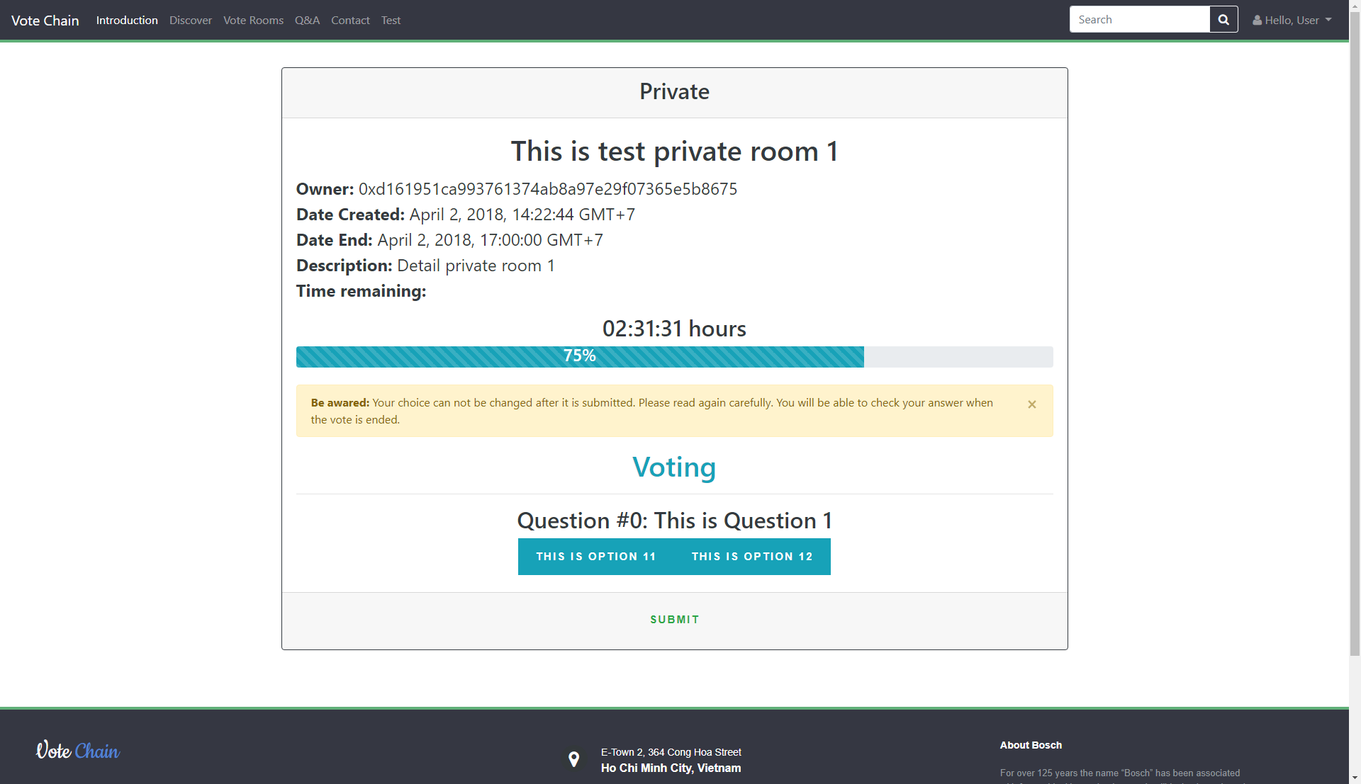

# Join Room

At the Index page, click on the “Vote Rooms”.

At the Vote Rooms page, you can see all the room in the network. However, you only can read the detail and vote for the Public Room. If you want to vote for the Private Room, click the button Check Eligible, Login and you will see all the eligible room (both Public and Private).

Click on any room you want to join.

Index page:

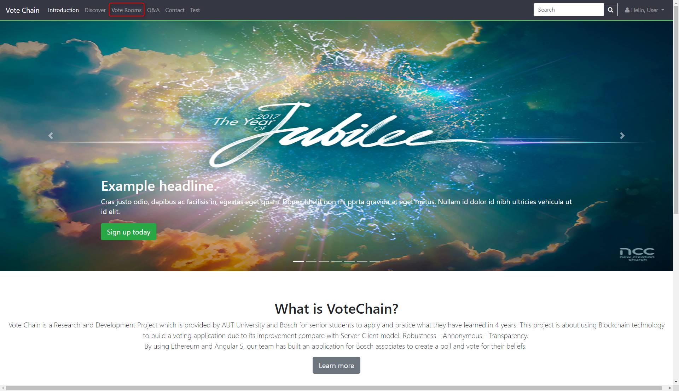

Vote Rooms page:

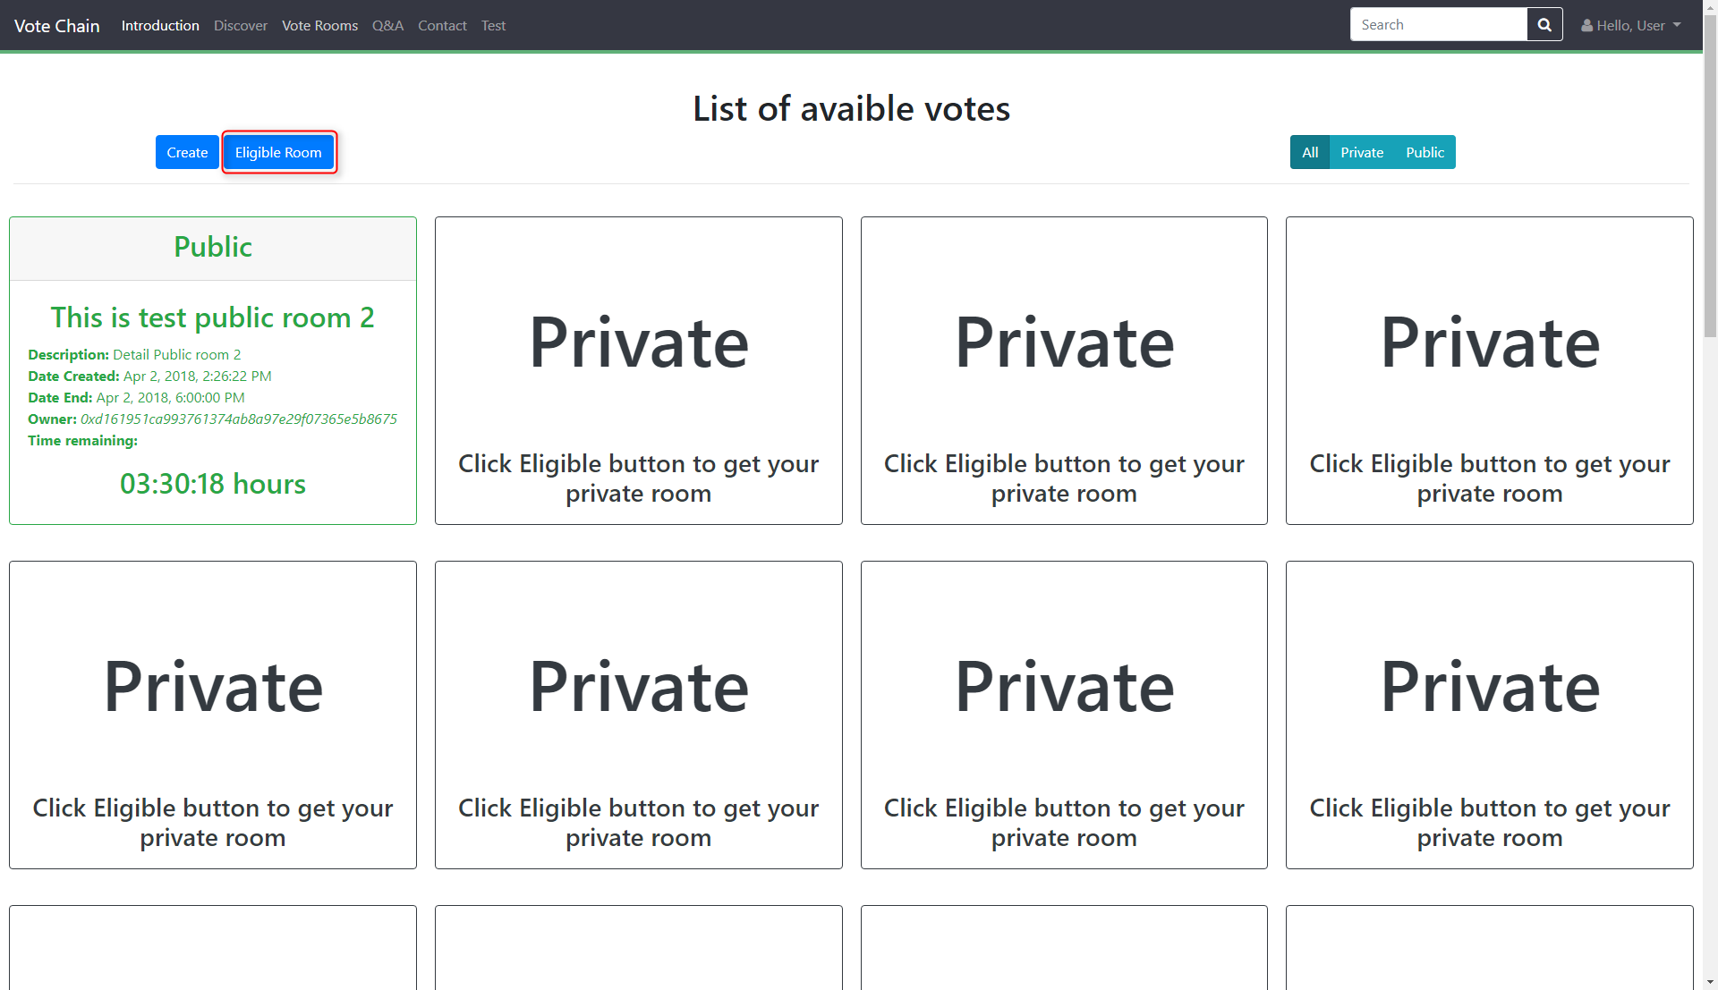

Before check Eligible Room:

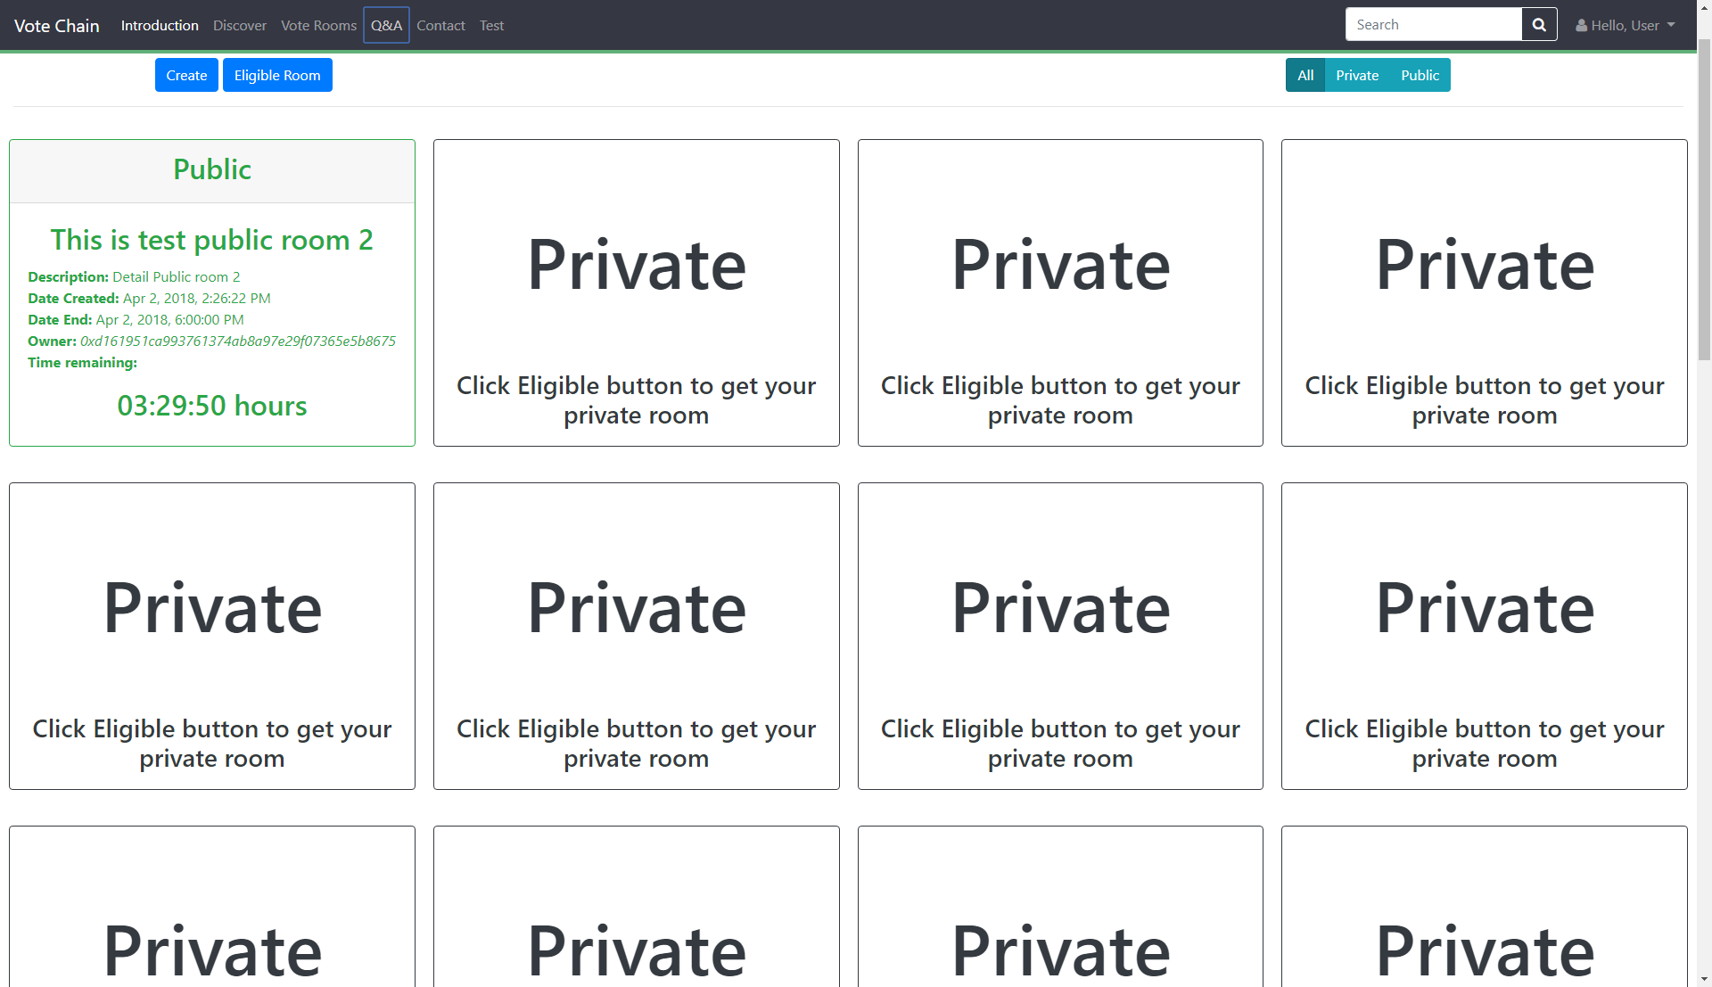

After check Eligible Room:

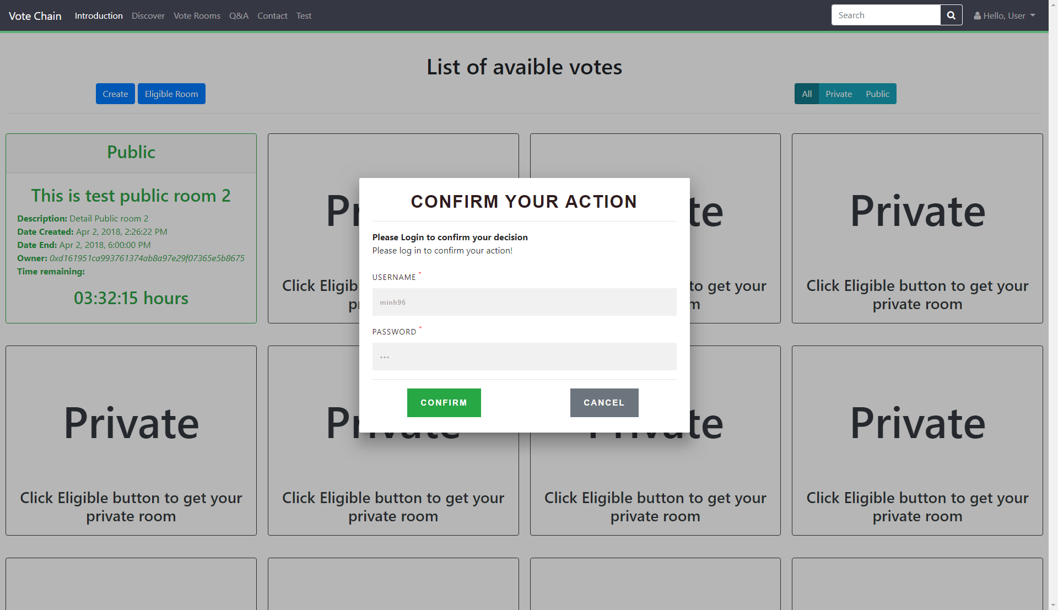

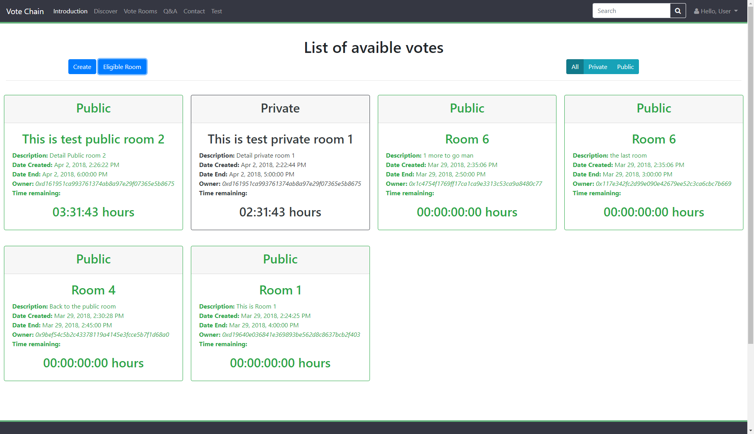

# Vote

At the Room you had joint in, you will able to see Time when the vote end, detail of the vote, questions and options.

Select you option for each question, re-check before submitted because it won’t be able to change anymore.

One-Person-One-Vote

Room:

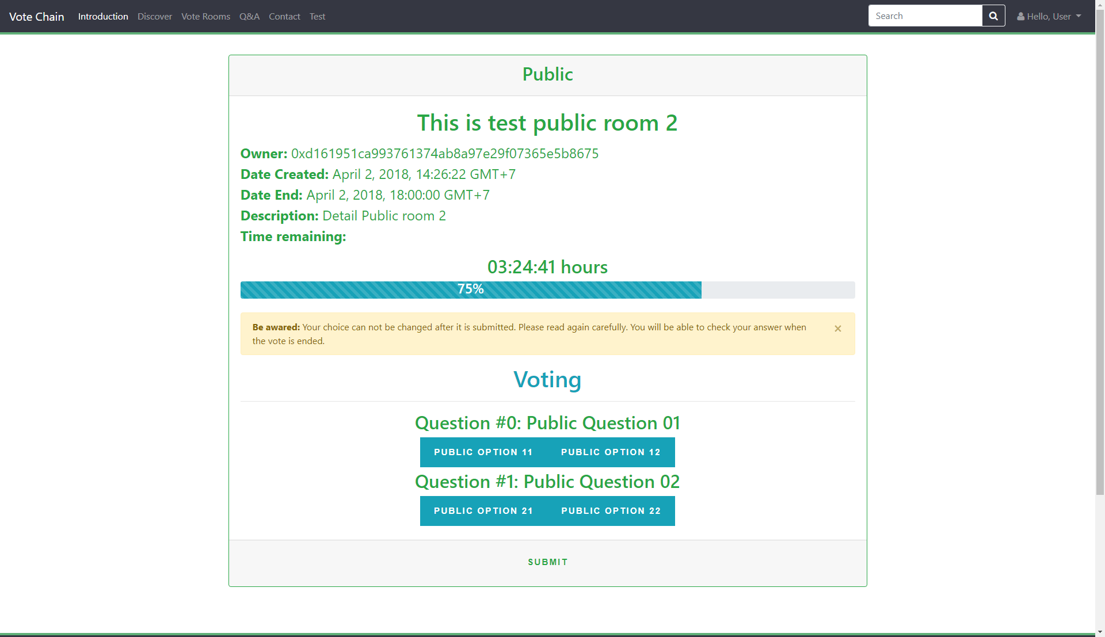

Login to confirm:

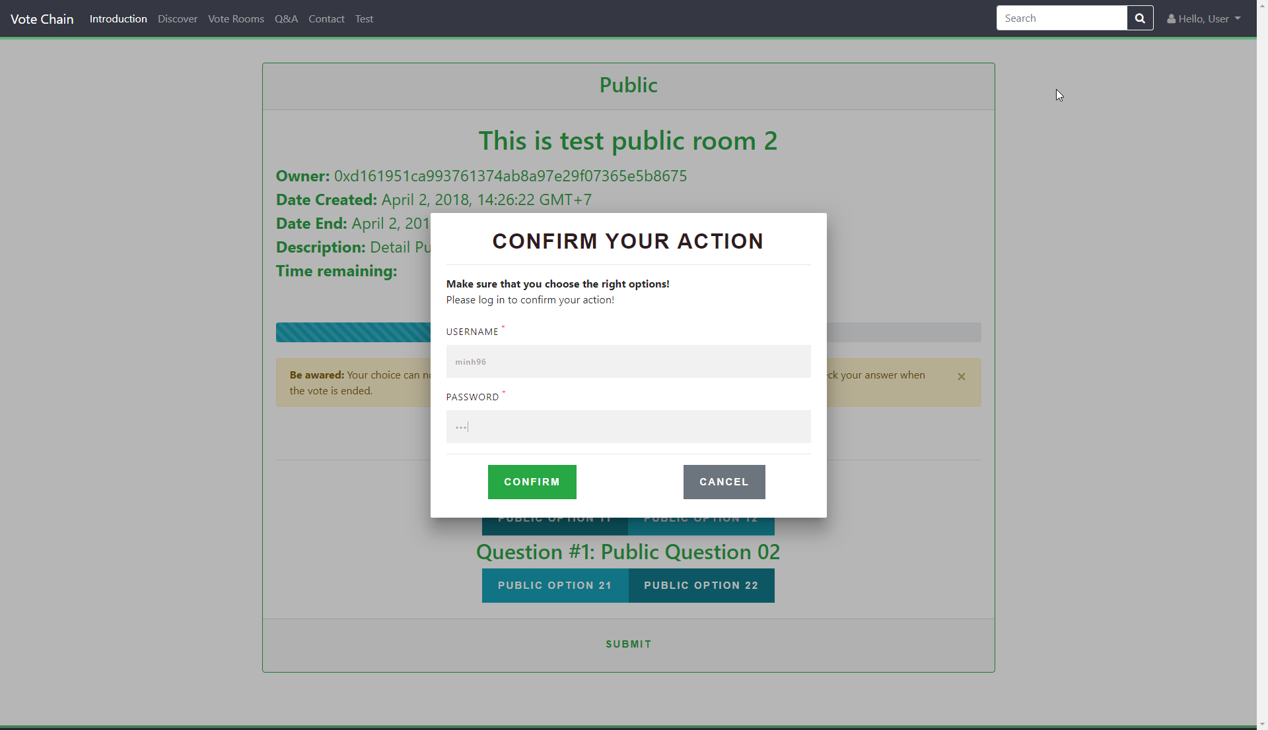

Submitting: 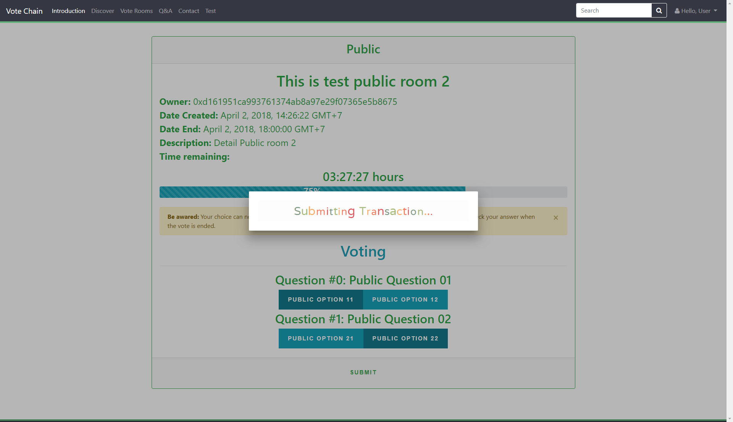

Success:

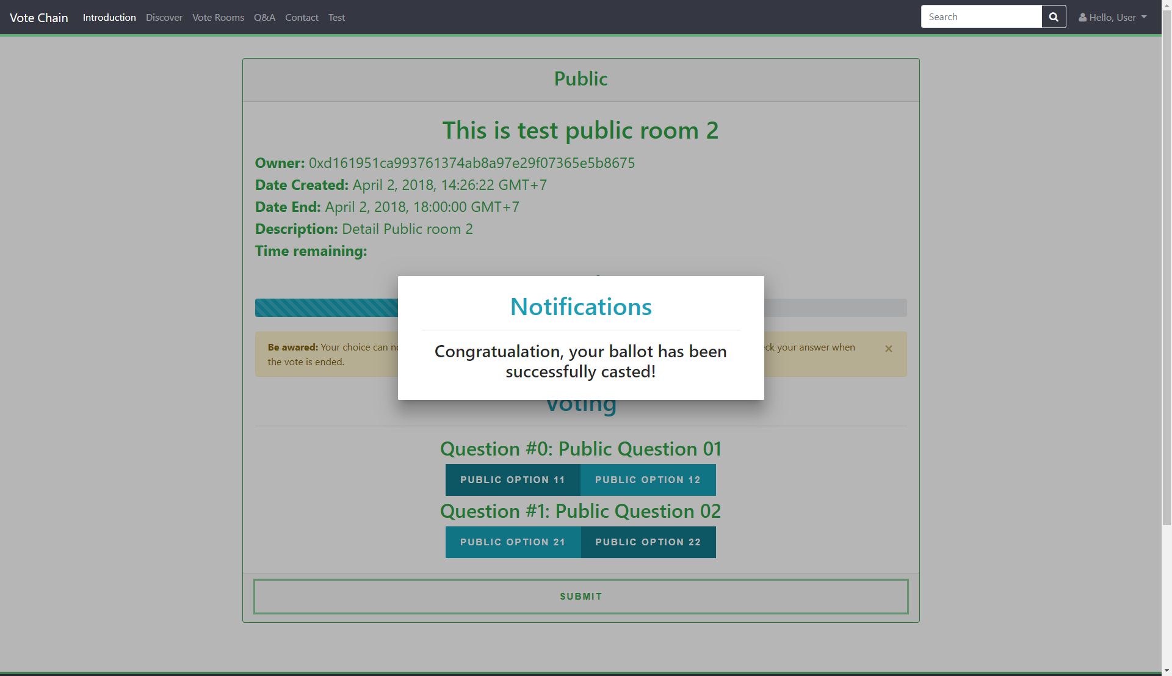

Error:

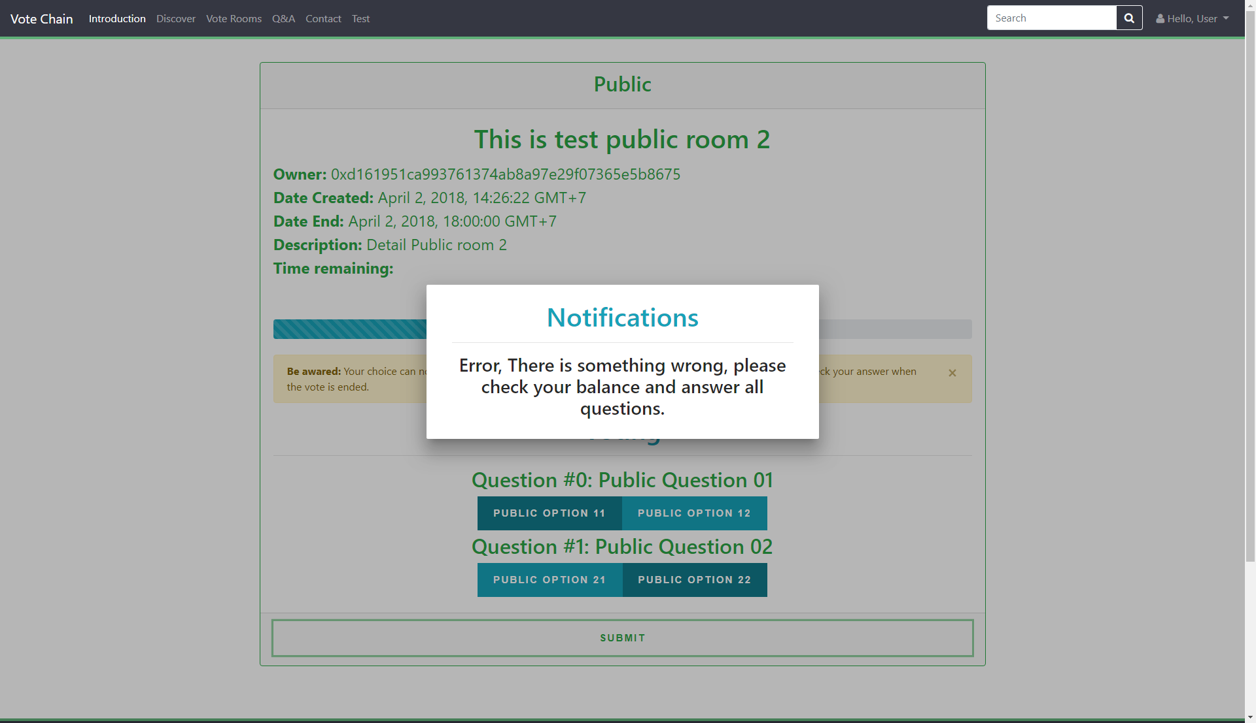

# Check Result

The result only appear when the vote end (Time condition). At that time, you can see the Option and the number of people vote for that. Click on the “Detail Result” button to see in detail.

Result of the vote:

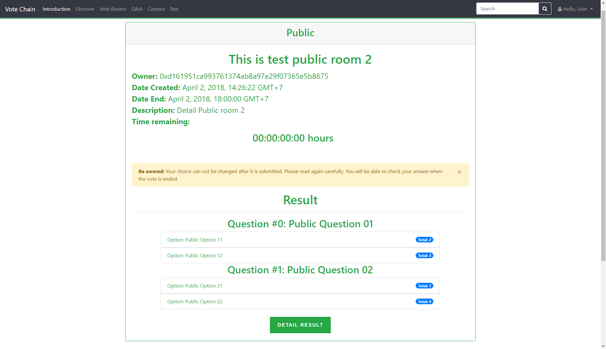

Result in detail:

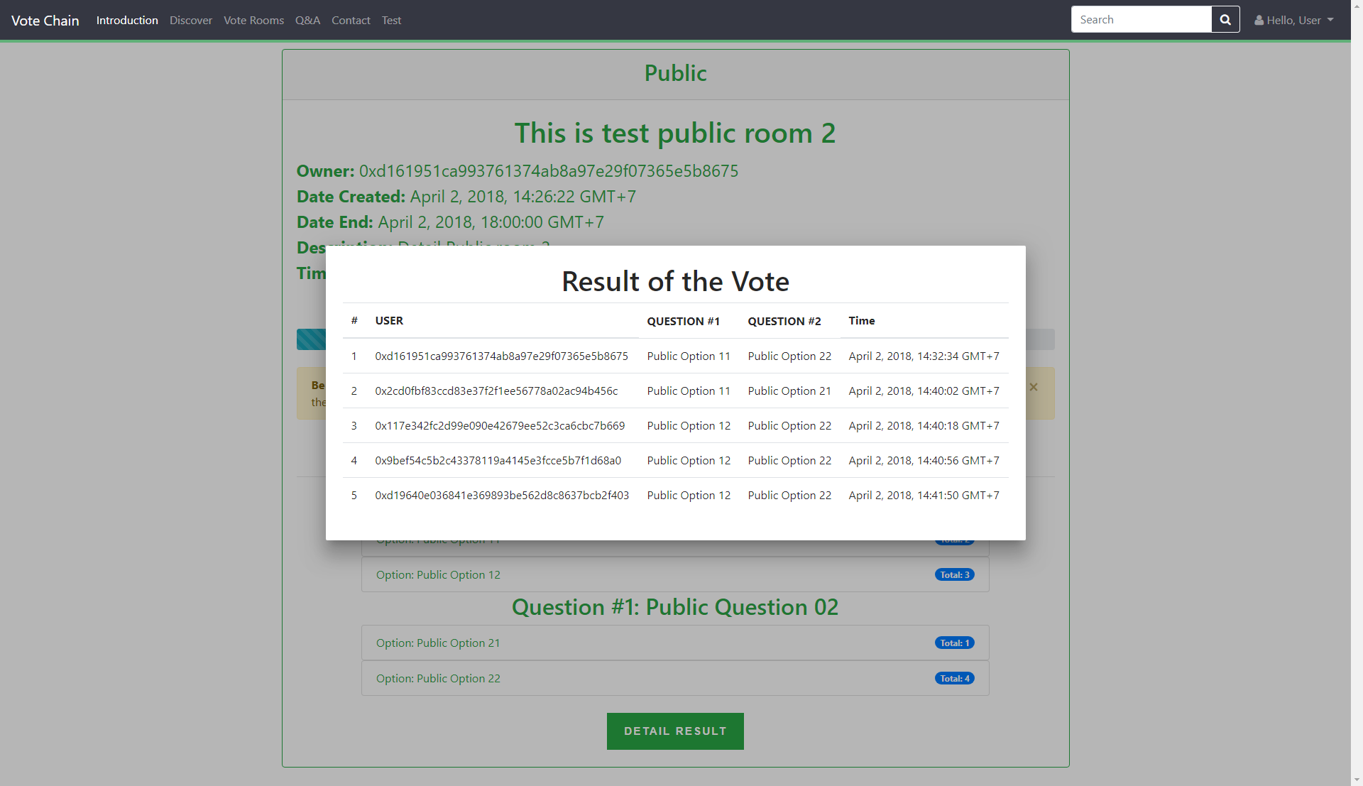

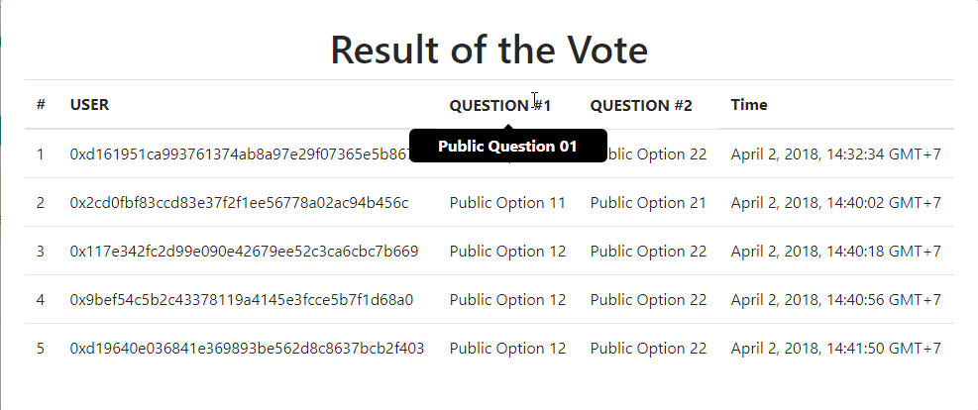

# Check History

At the Index page, click on the “Hello, User”, input your ID and password, then click Log In. You will be redirected automatically into your history page.

At the History page, you will see everything you have done.

Index page:



History page: 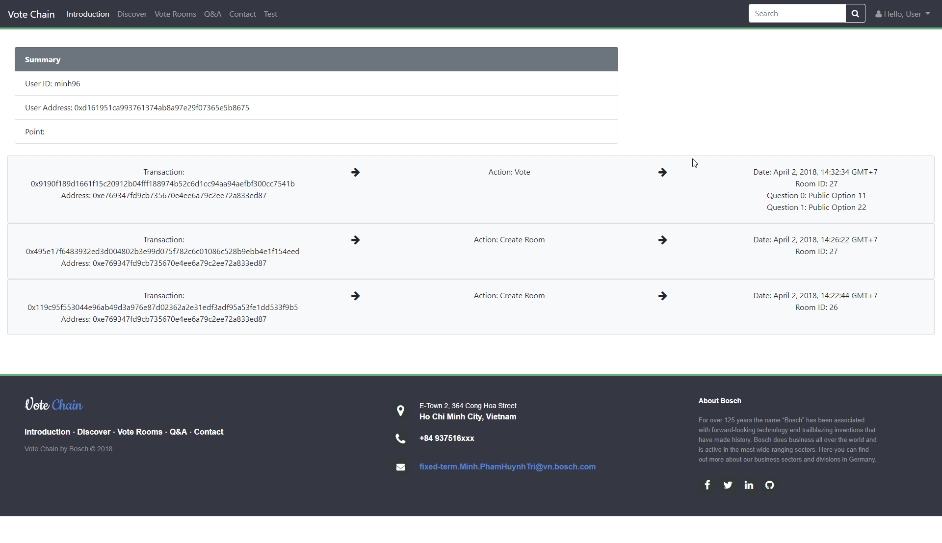

Error:

